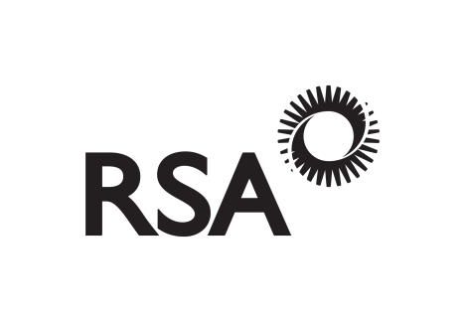

Professional Fitting & Treatment Liability Policy Schedule

Master Policy Number RKK662479
Policyholder | Kay Sian Lewis
Certificate Number | RKKM02235
Cover From | 1ST January 2022
Cover To | 1st January 2023
Premium (inclusive of Insurance Premium Tax at 12%) | £300
Business | Wax Management professional involved in the removal of ear wax including micro suction, wax-related issues and advice on wax-related issues.
Number of insured Persons | One

Section 2- PUBLIC/ PRODUCTS LIABILITY/PROFESSIONAL INDEMNITY LIMITS OF INDEMNITY
£5, 000,000 | Any One Event
£5, 000,000 | All Events happening during any Period of Insurance in respect of products supplied.
£5,000,000 | All incidents considered by the Company to have occurred during any Period of Insurance in respect of pollution or contamination of buildings or other structures or of water or land or of the atmosphere.

Section 3- LEGAL DEFENCE COSTS LIMITS OF INDEMNITY
Not Insured | Part A - Not applicable as applies to Section 1 - Employers Liability.
£250,000 | Part B - The total amount payable by the Company in respect of all costs and expenses arising out of all claims during any Period of Insurance.

POLICY EXCESS

The Policyholder is responsible for the first £200 of any one claim in respect of loss of or damage to Property made under this policy.
Insurer | Royal & Sun Alliance Insurance Plc
Branch | 17 York Street, Manchester, M2 3RS
Agency | Barry Fenton Insurance
Issue Date | 23rd December 2021
Signed | Gemma Burke
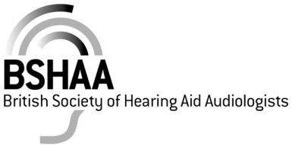
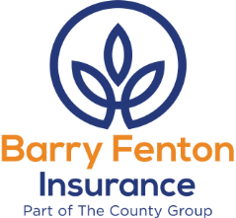

SECTIONS APPLICABLE
The insurance by this policy indemnifies the Policyholder in respect of Public/Products Liability and Professional Indemnity only and the associated Legal Defence Costs.

The following sections of the policy booklet are not insured and do not form part of this scheme

Section 1 - Employers Liability
Section 4 - Financial Loss

PROFESSIONAL INDEMNITY & TREATMENT EXTENSION
Exclusion 2 to Section 2 is deleted.

Where injury has not occurred Section 2 is extended to provide indemnity against legal liability in respect of claims for breach of professional duty consequent upon any neglect error or omission in providing advice treatment or prescriptions in the course of the business.

The Limit of Indemnity for this extension is £5,000,000 Any One Event.

Subject otherwise to the terms of the Policy.

RETROACTIVE COVER EXTENSION
The indemnity provided by Section 2 is extended to indemnify the Policyholder in respect of Injury of any person or loss of or damage caused prior to the inception of this insurance but for which a claim is first made against the Policyholder during the Period of Insurance.

This extension shall apply only in so far as the Policyholder is unable to obtain indemnity under any previous policy of insurance in respect of such Injury or damage provided that the inability of the Policyholder to obtain indemnity under a previous policy is not due to such Injury or damage being excluded under the terms of such policy or insurance or the breach of any policy condition or the non-disclosure or misrepresentation or concealment of a material fact.

Subject otherwise to the terms Conditions and Exclusions contained in the Policy.

Barry Fenton Insurance are authorised and regulated by The Financial Conduct Authority and Royal & Sun Alliance Insurance plc (No. 93792) are authorized by the Prudential Regulation Authority and regulated by the Financial Conduct Authority and the Prudential Regulation Authority.

